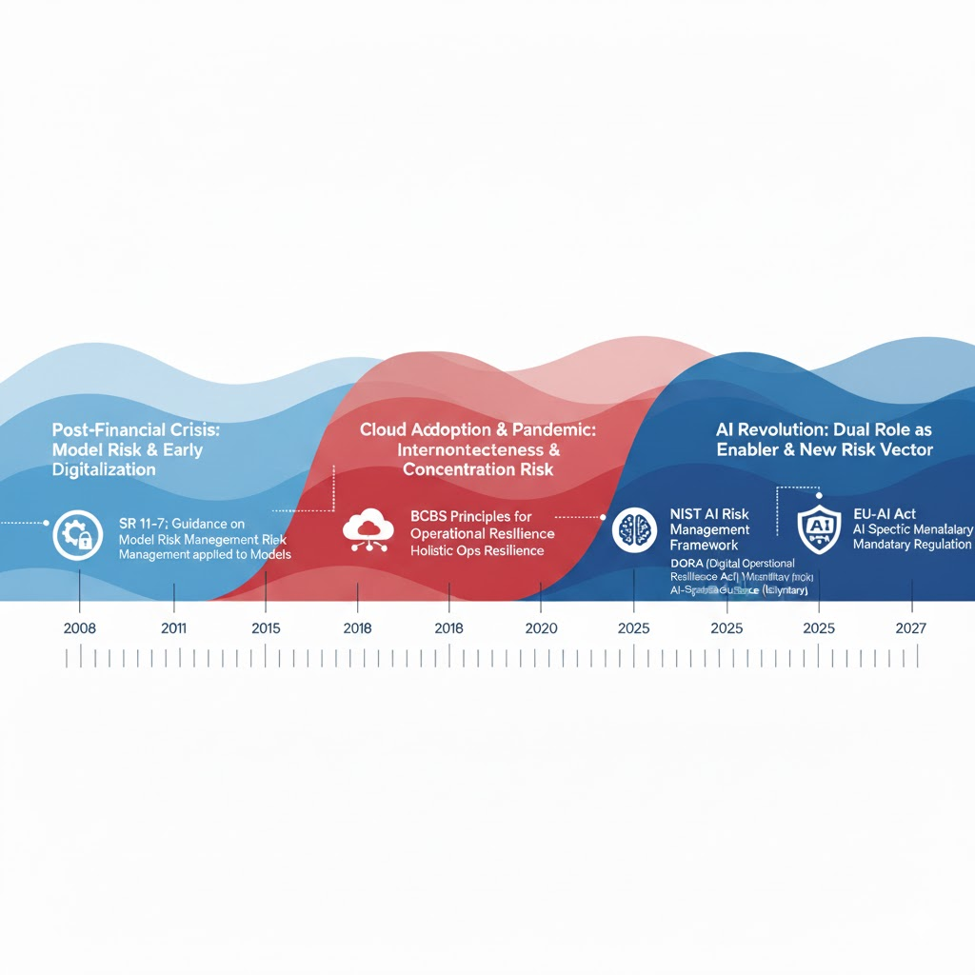
For decades, the concept of operational resilience was a simple, siloed affair known as "Business Continuity Planning" (BCP). It lived in a binder on a shelf, asking a basic question: "If our data center floods, how do we turn our backup systems on?" It was a reactive plan focused on recovering internal assets.
This entire philosophy has been rendered obsolete. The story of modern operational resilience is one of regulatory bodies playing catch-up with three successive waves of systemic risk: interconnectedness, concentration, and intelligence.

Wave 1: The 2008 Financial Crisis and the Ghost in the Machine
The 2008 financial crisis was the first wake-up call. It wasn't a flood or a fire that brought the system down; it was a catastrophic failure of complex, interconnected financial models. Regulators realized for the first time that an organization could be destroyed from within by its own "black box" tools.
The response was SR 11-7 in the US, a regulation that, in hindsight, was the first shot in AI governance. It forced banks to stop blindly trusting their quantitative models. It mandated rigorous model validation, governance, and monitoring. The regulatory lesson was: You are responsible for the logic you build, even if you don't fully understand it. This set the stage for all future AI regulation.

Wave 2: The Cloud & COVID-19 Pandemic — The Great Concentration
The second wave was a one-two punch that exposed a new, terrifying vulnerability: concentration risk.
- The Cloud Shift: Over the 2010s, firms raced to decommission their expensive data centers and move to the cloud, drawn by efficiency and scalability.
- The COVID-19 Pandemic: In 2020, this shift became a stampede. The entire global workforce moved remote overnight, enabled almost entirely by a handful of "hyperscaler" cloud service providers (CSPs).
Suddenly, regulators had a horrifying realization: the entire global financial system was now existentially dependent on the operational resilience of just three or four tech companies. The old BCP model was useless. You can't "failover" from a global AWS or Azure outage.
This panic led directly to the new generation of holistic regulations, most notably the Digital Operational Resilience Act (DORA) in the EU and similar principles from the BCBS.
This was a paradigm shift. The focus moved from "recovering my assets" to "maintaining my critical business services." DORA’s five pillars—ICT Risk Management, Incident Reporting, Resilience Testing, Information Sharing, and especially Third-Party Risk Management—are built on a new lesson: You are only as resilient as the third-party providers you depend on.
For the first time, DORA gives regulators direct oversight over "Critical Third-Party Providers," meaning they can now audit the cloud providers themselves.

Wave 3: The AI Revolution — The Dual-Role Dilemma
We are now in the third wave, where AI is simultaneously becoming the most powerful tool for managing resilience and the most complex new risk that must be made resilient.
1. AI as the Resilience Solution: AI is changing traditional, reactive resilience practices into proactive, predictive ones.
- Traditional: "A server has failed. Let's find out why."
- AI-Powered: "Our AI model, monitoring 50,000 data points a second, detected a subtle performance degradation and predicts a 95% chance of server failure in the next 72 hours. A work order has been created, and workloads are already being shifted."
In this space, AI is used for advanced anomaly detection, predictive maintenance, and NLP models that scan global news to predict supply chain disruptions before they happen.
2. AI as the New Systemic Risk: Just as firms become dependent on AI, they inherit a new class of risks that traditional frameworks can't handle:
- Model Drift: The AI model works perfectly today, but over time, the real world "drifts" from its training data, and its predictions become silently, dangerously wrong.
- Data Poisoning: A malicious actor feeds the AI subtly "poisoned" data, teaching it to make a catastrophic error at a specific future moment (e.g., approve a billion-dollar fraudulent transaction).
- Opaqueness (The "Black Box"): The AI solves a problem, but you don't know how. This makes it impossible to validate under old rules like SR 11-7.
This brings the narrative full circle. The new wave of AI-specific regulation is, in reality, the next evolution of operational resilience.
- The NIST AI Risk Management Framework is a guide for building "trustworthy" AI, but its core tenets—Govern, Map, Measure, Manage—are resilience principles for this new asset class.
- The EU-AI Act mandates that high-risk AI systems must be "robust," "accurate," and "secure." These are not just tech buzzwords; they are the new legal and regulatory definitions of operational resilience for an intelligent system.
In essence, the regulatory landscape has evolved from worrying about a single server in a basement, to overseeing global cloud providers, and now, to governing the integrity of the very logic and intelligence that runs the business.

The Evolution of Resilience Regulation: From Operational Risk to AI Governance
Regulation Name | Date Implemented | Applicable Region | Bullet Points of Requirements (Concise) | Talking Point (Background & Relevance)
SR 11-7: Guidance on Model Risk Management | April 4, 2011 | US (Financial Institutions) | • Model Validation: Requires robust validation of model inputs, processing, and outputs.  • Governance: Mandates a strong governance framework, including board oversight and clear roles.  • Documentation: Requires comprehensive documentation for all model components and processes.  • Ongoing Monitoring: Requires continuous monitoring to ensure models perform as intended over time. | Background: This was a direct response to the 2008 financial crisis, which was heavily fueled by the failure and misuse of complex financial models (e.g., for mortgage-backed securities).  Relevance: While pre-dating the modern AI boom, SR 11-7 is the foundational framework for AI/ML model governance in US banking. Regulators apply its principles directly to AI, making it a "traditional" rule that now governs AI resilience.
BCBS: Principles for Operational Resilience | March 31, 2021 | Global (Banking - Basel Committee member jurisdictions) | • Governance: Establish a clear operational resilience approach and governance structure.  • Identify Critical Operations: Identify and map critical operations, processes, and supporting resources.  • Set Impact Tolerances: Define tolerance for disruption for each critical operation.  • Testing: Test the ability to remain within impact tolerances through severe but plausible scenarios.  • Third-Party Risk: Manage dependencies on third-party service providers. | Background: Published in the wake of the COVID-19 pandemic and rising, sophisticated cyber-attacks (like ransomware). Regulators saw that "Business Continuity Planning" was no longer enough.  Relevance: This marked a significant global shift from reactive disaster recovery to proactive operational resilience. The focus moved from "how do we recover our systems?" to "how do we continue serving our critical customers during a disruption?"
NIST AI Risk Management Framework (RMF 1.0) | January 2023 | US (Voluntary, but globally adopted) | • Govern: Cultivate a risk management culture and establish processes for all AI activities.  • Map: Contextualize risks; identify the AI system's purpose, benefits, and potential harms.  • Measure: Assess, analyze, and track identified AI risks (e.g., bias, security, robustness).  • Manage: Allocate resources to treat risks; prioritize, respond to, and monitor residual risks. | Background: Created as AI systems (especially large language models) became mainstream. It addresses risks that traditional software frameworks don't, such as fairness, bias, interpretability, and privacy.  Relevance: This is not a law, but a "best practice" framework. It's the go-to guide for how to build trustworthy and resilient AI. It provides the "how-to" for managing the specific, new risks AI introduces, which traditional ops resilience rules don't cover.
Digital Operational Resilience Act (DORA) | January 17, 2025 (Application Date) | European Union (Financial Services) | • ICT Risk Management: Implement a comprehensive, well-documented ICT risk framework.  • Incident Reporting: Harmonize and streamline reporting of major ICT incidents to regulators.  • Resilience Testing: Mandates regular basic and (for critical firms) advanced testing, like Threat-Led Penetration Testing (TLPT).  • Third-Party Risk: Establishes direct oversight of "Critical Third-Party Providers" (like cloud providers). | Background: DORA was created because EU regulators saw that financial firms were heavily reliant on a small number of tech and cloud providers. A failure at one of these providers could destabilize the entire EU financial system.  Relevance: This is the most comprehensive digital resilience law to date. It explicitly links ICT and third-party risk to operational resilience. It's the first major law to regulate the tech suppliers to the financial industry, not just the financial firms themselves.
EU-AI Act | (Phased) 2025 - 2027 | European Union | • Risk-Based Approach: Classifies AI into Unacceptable (banned), High, Limited, and Minimal risk.  • High-Risk Requirements: Mandates strict rules for high-risk systems, including:  • Robustness & Accuracy: Must perform consistently and securely.  • Cybersecurity: Must be resilient against attacks and vulnerabilities.  • Data Governance: Requires high-quality, unbiased training data.  • Human Oversight: Must be designed to allow effective human control. | Background: This is the world's first comprehensive, binding law for AI. It was prompted by the rapid proliferation of AI and the potential for it to cause systemic harm to health, safety, and fundamental rights.  Relevance: This act codifies AI resilience into law. It directly addresses AI-specific failures (e.g., model drift, data poisoning) by setting technical standards for robustness and cybersecurity. It essentially creates "AI-specific operational resilience" requirements for any high-risk system deployed in the EU.

